Phase 1 Test Cases

Test Case 1: Task Creation and Scheduler Setup
In this test, we create multiple tasks using the scheduler to make sure tasks are being created and stored correctly. We create Task1, Task2, and Task3 and confirm that each task is added properly. This test shows that the scheduler is able to handle multiple tasks.

Output:
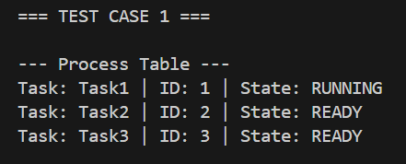

Test Case 2: First Task Gets Semaphore Access
In this test, the first task tries to access the shared resource using the semaphore. Since the resource is free, Task1 is able to get access. This shows that the semaphore allows one task to use the resource when it is available.

Output:

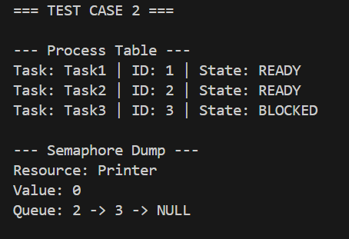

Test Case 3: Other Tasks Get Blocked
In this test, Task2 and Task3 try to access the same resource while it is already in use. Both tasks get blocked. This shows that the semaphore correctly stops multiple tasks from using the resource at the same time.

Output:

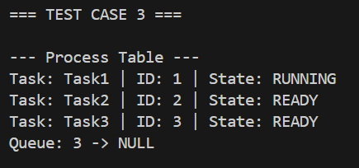

Test Case 4: Semaphore Release and Resume
In this test, we release the resource using sem.up(). After that, the blocked tasks are able to continue. This shows that the semaphore correctly manages waiting tasks and gives access again when the resource is free.

Output:

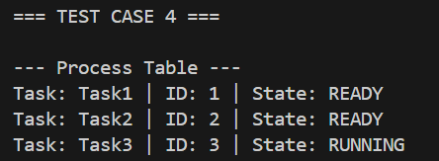

Verification Method
For all tests, we use the dump() functions in both the scheduler and semaphore classes. This lets us see the internal state of the system at different steps and confirm that task states and resource control are working correctly.

Code Snippets

Task Creation (Scheduler Setup):
We create multiple tasks using the scheduler by calling create_task() for Task1, Task2, and Task3. This sets up each task and stores it inside the scheduler so they can be managed and scheduled properly. This step shows that we are able to successfully create and track multiple tasks in the system.
Code Snippet Screenshot:
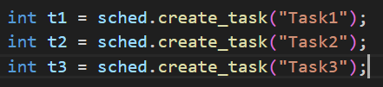

Semaphore Acquire (Lock Resource):
We use sem.down(sched.get_current()) to let the current task try to access the shared resource. If the resource is available, the task is allowed to enter the critical section. If it is already in use, the task gets blocked. This shows that we are properly controlling access so only one task uses the resource at a time.
Code Snippet Screenshot:

Semaphore Release (Unlock Resource):
We use sem.up() to release the shared resource after a task is finished using it. This allows other blocked tasks to gain access again. This step shows that we are correctly managing the semaphore so waiting tasks can continue when the resource becomes available.
Code Snippet Screenshot:
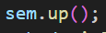

Scheduler Yield (Context Switch):
We use sched.yield() to switch from the current task to another ready task. This allows the scheduler to move between tasks fairly instead of letting one task run forever. This shows that we are correctly handling context switching in the system.

Code Snippet Screenshot:
Debug Output (System State Verification):
We use sched.dump(1) and sem.dump(1) to print the internal state of the system at different points. This helps us confirm that tasks are in the correct states (RUNNING, READY, BLOCKED) and that the semaphore is correctly tracking access and waiting tasks. This step helps us verify that the system is working as expected.
Code Snippet Screenshot:
